**Project Report On**

**Resume Create App**

**BCA**

**Semester - 6**

**Submitted By**

**Prakash Gohil**

**Guide**

**Prof. Kishorsinh Vala**

**Submitted To.**

**Geetanjali College of Computer Science and Commerce(BBA),Redcross Building, Opp. Shastri-Maidan, Suchak Road, Rajkot-360003**

**Acknowledgment**

* In order to pursue a B.Sc.IT degree in the computer branch at Saurashtra University, Rajkot, I am pleased to submit my concept for the "Resume Center" Application.
* I appreciate all of the faculty at the Department of Computer Science, especially the department head, Prof. Brijesh Shah, for their kind assistance during this process.
* I'd want to take this opportunity to thank the eminent authors of the countless books, papers, and blogs we've cited thus far.
* I also want to express my gratitude to my parents for their help and support. Without them, I would be unable to do anything in life or in my endeavors. I'm appreciative of my family's support.
* The want to express my gratitude to anyone for their assistance comes directly from my heart. A little but crucial and timely favor can turn out to be a turning point in someone's life.

**Index**

|  |  |  |
| --- | --- | --- |
| Project Profile | **:** | **1** |
| System Development Life Cycle | **:** | **2** |
| System Requirement Specification | **:** | **7** |
| About the tools and technologies | **:** | **8** |
| Use Cash Diagram | **:** | **11** |
| Data Flow Diagram | **:** | **12** |
| Entity Relationship Diagram | **:** | **13** |
| Data Dictionary | **:** | **14** |
| Screen Shots | **:** | **19** |
| Test Cases | **:** | **32** |
| Limitations | **:** | **35** |
| Future Enhancement | **:** | **35** |
| Webliography | **:** | **36** |

**Project Profile**

|  |  |  |
| --- | --- | --- |
| Project Title | : | Resume Center Application |
| Development Software | : | Android Studio |
| Frontend | : | Android |
| Backend | : | Firebase Database |
| Academic Year | : | 2022-2023 |
| Developed By | : | Prakash Gohil |
| Submitted To | : | Geetanjali College |
| Documentation Tool | : | Microsoft Word |
| Operating System | : | Android |
| Language | : | Kotlin |
|  |  |  |

**System Development Life Cycle**

For the development of this project I have follow the simple waterfall model of SDLC.

The Waterfall Model was the first Process Model to be introduced. It is also referred to as a linear-sequential life cycle model. It is very simple to understand and use. In a waterfall model, each phase must be completed before the next phase can begin and there is no overlapping in the phases.

The Waterfall model is the earliest SDLC approach that was used for software development.

The waterfall Model illustrates the software development process in a linear sequential flow. This means that any phase in the development process begins only if the previous phase is complete. In this waterfall model, the phases do not overlap.

Steps : 1 - Requirement gathering

2 - Project Planning

3 - Design

4 - Coding & Implementation

5 - Testing

1 - Requirement gathering

Any software development process must include the requirement gathering stage. After choosing the project topic, one must research every criteria needed to construct that specific project.

I began gathering requirements for my Resume Center application from the various resume & CV apps that are offered in the Google Play market. In order to learn about the necessary functionality needs for resume or CV applications.

Features that are needed in application for users are as follows:

1. Create Resume -

Create Resume is the main feature of the user side application that will be used to make resume.

1. Personal Information -

Personal Information is the feature that will be used to gathering information from the user.

1. Educational Information -

Educational Information is the feature that will be used to gathering information from the user.

1. Skill Information -

Skill Information is the feature that will be used to gathering information from the user.

1. Experience Information -

Experience Information is the feature that will be used to gathering information from the user.

1. Reference Information -

Reference Information is the feature that will be

used to gathering information from the user.

1. Select Theme -

Select Theme is the feature that will be used to show users resume date in proper layout or design.

1. Download Resume -

Download Resume is the feature that will be used to download resume as PDF format.

1. Logout -

Logout is the feature that will be used to logout user I'd from the Resume Center Application.

2 - Project Planning

Making a project plan comes next, after the requirement collection phase has been completed. The amount of project modules must be determined, and the optimal technology for development must be selected.

To create the existing project, choosing technologies in this case means selecting front end and back-end technology.

User side XML produced layouts are utilized for this project's front-end technology, and Kotlin is used as the coding language for any operations based on user interaction with the user interface.

Firebase is utilized as the back end for both the user sides in order to provide authentication services and to store data.

3 - Design

This process can be broken down into two parts: the preliminary design and the final design. The project's basic layout is generated on paper or using any design program during the preliminary design phase, and the development team then evaluates the design's viability.

The second phase is final design, in which the project's final or nearly accurate design is constructed after earlier concepts have been evaluated for practicality and flaws have been identified.

4 - Coding & Implementation

The actual application is coded in the chosen programming language following the collection of all requirements, customer approval of the design, and feasibility assessment of the project. The SDLC's longest phase is regarded as being this one. To finish this level, we need various tools including IDEs, browsers, and backend tools.

To avoid confusion throughout the coding phase, I also adhere to the following coding standards:

Coding Standard :

1. Give the variable names based on the activities in which they are present. For example, if a variable is present in a category Activity, its name must begin or end with a cat or category phrase.

2. Whenever an array is constructed, the Array suffix is utilized.

3. Data classes that are used are given names based only on their activity.

4. An Adapter suffix is required for adapter classes.

5. All variables and files must have camel case names.

6. Functions for data loading employ get prefix.

The application development divided to two phases, which are:

1. Database making

Database is made based on the design. It used Firebase Real-Time Database which will be related between the applications developed in Android OS.

b. Application development

This phase is translating the result of design into android Programming for user.

5 - Testing

The application is ready to be tested for usability and to see if it is operating as planned once the coding and implementation phases are complete.

For testing purpose, I shared my app with my colleagues to verify its functions and user friendliness. Till app does not function as intended this SDLC process repeats itself from first step to last.

**System Requirement Specifications**

To develop this project , the following system hardware and network are required :

Minimum Hardware Requirement –

For Android Application:

|  |  |
| --- | --- |
| Operating System | Windows 7 |
| CPU/Processor | Intel i3 |
| Ram | 4 GB |

Software Requirements –

|  |  |
| --- | --- |
| Services Required | Firebase |
| Android API | Android 5.0(API 22) |

**About The Tools & Technologies**

**Android Studio:**

Built on JetBrains' IntelliJ IDEA software and created exclusively for Android development, Android Studio is the recognized integrated development environment (IDE) for Google's Android platform. On Windows, macOS, and Linux-based operating systems, it can be downloaded. As the main IDE for creating native Android applications, it takes the position of the Eclipse Android Development Tools (E-ADT).

At the Google I/O conference on May 16, 2013, Android Studio was unveiled. Beginning with version 0.1 in May 2013, it was in the early access preview stage. From version 0.8, which was released in June 2014, it moved into the beta stage. Starting with version 1.0, the first stable build was released in December 2014. Google stopped supporting Eclipse ADT at the end of 2015, leaving just Android Studio as an officially approved IDE for Android development.

**Kotlin:**

A cross-platform, statically typed, general-purpose, high-level programming language with type inference is called Kotlin (/ktln/). Although Kotlin is intended to work seamlessly with Java and the JVM version of its standard library depends on the Java Class Library, type inference enables more concise syntax.

Kotlin primarily targets the JVM, although it may also be compiled to JavaScript or native code using LLVM (for example, for front-end web applications using React) (e.g., for native iOS apps sharing business logic with Android apps).

JetBrains is responsible for language development costs, and the Kotlin Foundation is in charge of trademark protection.

Google declared that Kotlin is now its preferred programming language for Android app developers on May 7, 2019. In place of the default Java compiler, Kotlin has been available since the release of Android Studio 3.0 in October 2017.

**Firebase:**

A backend-as-a-service is Firebase (Baas). It offers a range of tools and services to developers so they can create high-quality apps, expand their user base, and make money. It is built using Google's technical framework. A NoSQL database application, Firebase stores data in documents that resemble JSON.

**Key Features**

1. Authentication

Passwords, phone numbers, Google, Facebook, Twitter, and other methods are all supported for authentication. One or more sign-in methods can be manually incorporated into an app using the Firebase Authentication (SDK).

2. Real-time database

Data is continuously available across all clients and is synced in real-time, even when an app is not running.

3. Hosting

A web app can be hosted quickly using Firebase Hosting thanks to content delivery networks all over the world being cached.

4. Test lab

On physical and virtual devices housed in Google's data centers, the application is tested.

5. Notifications

With Firebase, notifications can be sent without any additional coding.

**Word:**

MS Word enables users to do write-ups, create documents, resumes, contracts, etc. This is one of the most commonly used programs under the Office suite.

**Use Cash Diagram**

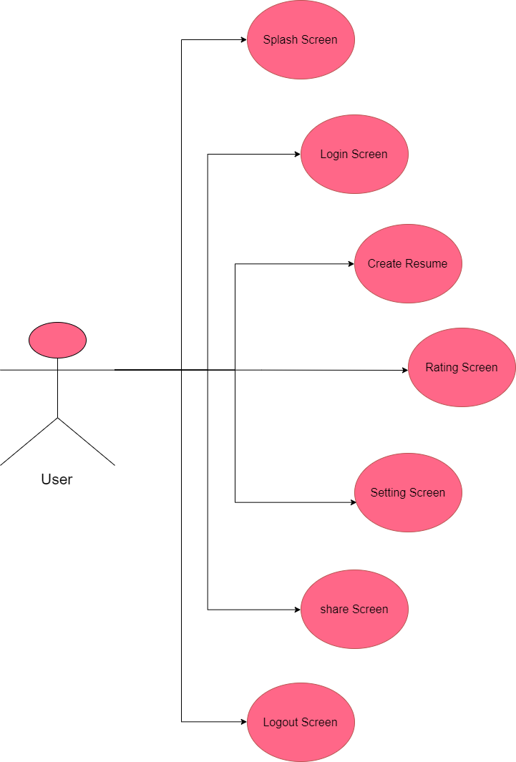

**Data Flow Diagram**

**User Side:**

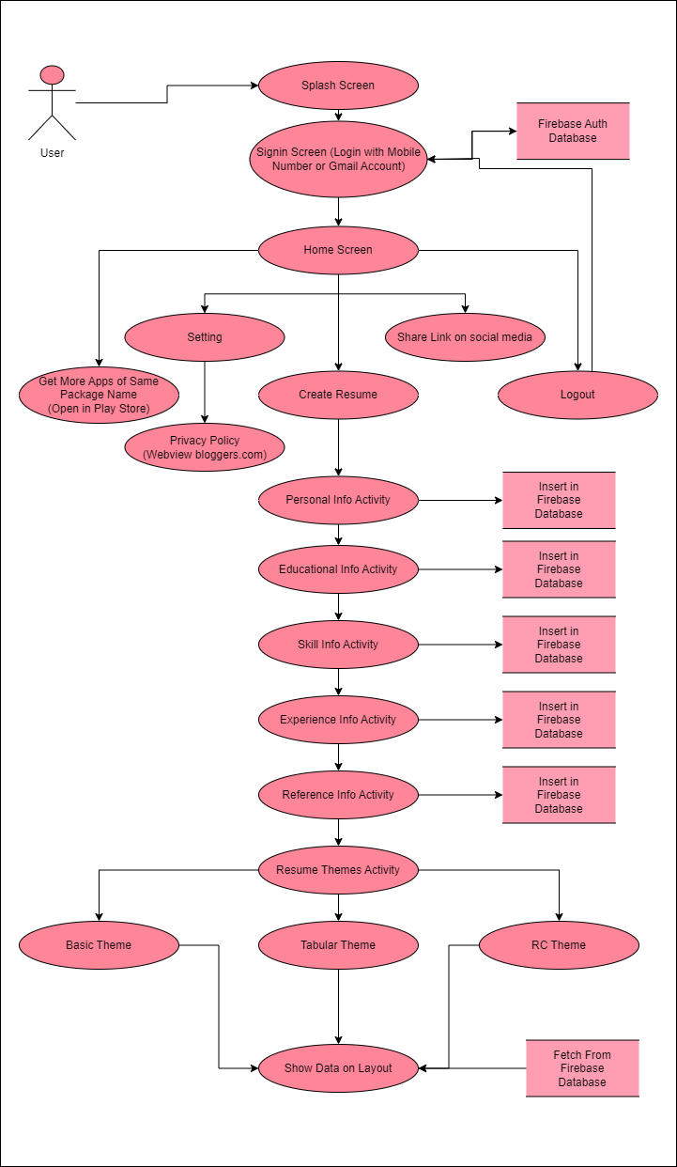

**Entity Relationship Diagram**

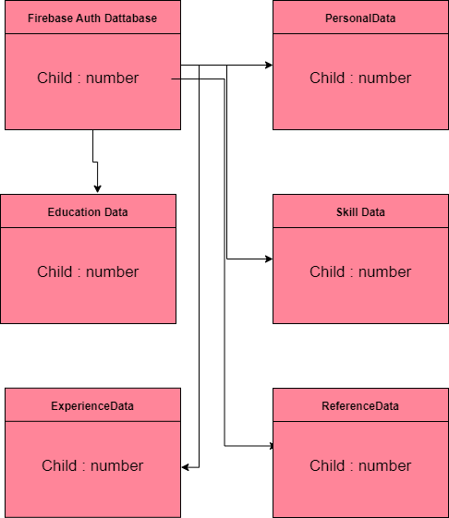

**Data Dictionary**

**Firebase Auth db**

|  |  |  |  |  |
| --- | --- | --- | --- | --- |
| **Sr. No.** | **Field** | **Data Type** | **Size** | **Constraint** |
| 1 | Number | String | - | - |

**personalData**

|  |  |  |  |  |
| --- | --- | --- | --- | --- |
| **Sr. No.** | **Field** | **Data Type** | **Size** | **Constraint** |
| 1 | Address | String | - | - |
| 2 | birthData | String | - | - |
| 3 | Birthplace | String | - | - |
| 4 | Cast | String | - | - |
| 5 | Country | String | - | - |
| 6 | District | String | - | - |
| 7 | Email | String | - | - |
| 8 | Gender | String | - | - |
| 9 | languageKnown | String | - | - |
| 10 | maritialSatus | String | - | - |
| 11 | Name | String | - | - |
| 12 | Nationality | String | - | - |
| 13 | Number | String | - | child |
| 14 | otherLanguageKnown | String | - | - |
| 15 | Religion | String | - | - |
| 16 | State | String | - | - |
| 17 | taluka | String | - | - |
| 18 | Village | String | - | - |
| 19 | website | String | - | - |

**educationData**

|  |  |  |  |  |
| --- | --- | --- | --- | --- |
| **Sr. No.** | **Field** | **Data Type** | **Size** | **Constraint** |
| 1 | Number | String | - | Child |
| 2 | collegeAddressUG | String | - | - |
| 3 | collegeAddressPG | String | - | - |
| 4 | collegeNameUG | String | - | - |
| 5 | CollegeNamePG | String | - | - |
| 6 | contact10 | String | - | - |
| 7 | contact12 | String | - | - |
| 8 | contactUG | String | - | - |
| 9 | contactPG | String | - | - |
| 10 | degreeName10 | String | - | - |
| 11 | degreeName12 | String | - | - |
| 12 | degreeNameUG | String | - | - |
| 13 | degreeNamePG | String | - | - |
| 14 | passingYear10 | String | - | - |
| 15 | passingYear12 | String | - | - |
| 16 | passingYearUG | String | - | - |
| 17 | passingYearPG | String | - | - |
| 18 | percentage10 | String | - | - |
| 19 | percentage12 | String | - | - |
| 20 | percentageUG | String | - | - |
| 21 | percentagePG | String | - | - |
| 22 | schoolAddress10 | String | - | - |
| 23 | schoolAddress12 | String | - | - |
| 24 | streamRadio | String | - | - |
| 25 | uniNameUG | String | - | - |
| 26 | uniNamePG | String | - | - |

**skillData**

|  |  |  |  |  |
| --- | --- | --- | --- | --- |
| **Sr. No.** | **Field** | **Data Type** | **Size** | **Constraint** |
| 1 | Number | String | - | Child |
| 2 | skillName | String | - | - |

**experienceData**

|  |  |  |  |  |
| --- | --- | --- | --- | --- |
| **Sr. No.** | **Field** | **Data Type** | **Size** | **Constraint** |
| 1 | Number | String | - | Child |
| 2 | companyName | String | - | - |
| 3 | jobTitle | String | - | - |
| 4 | location | String | - | - |
| 5 | position | String | - | - |

**referenceData**

|  |  |  |  |  |
| --- | --- | --- | --- | --- |
| **Sr. No.** | **Field** | **Data Type** | **Size** | **Constraint** |
| 1 | Number | String | - | Child |
| 2 | companyNameRef | String | - | - |
| 3 | locationRef | String | - | - |
| 4 | nameRef | String | - | - |
| 5 | contactRef | String | - | - |
| 6 | position | String | - | - |

**Screen Shoots**

**User Side:**

1 - Splash Animation Screen



* When app is open than first show splash animation screen and after automatically move on next screen.

2 - Sign In Screen

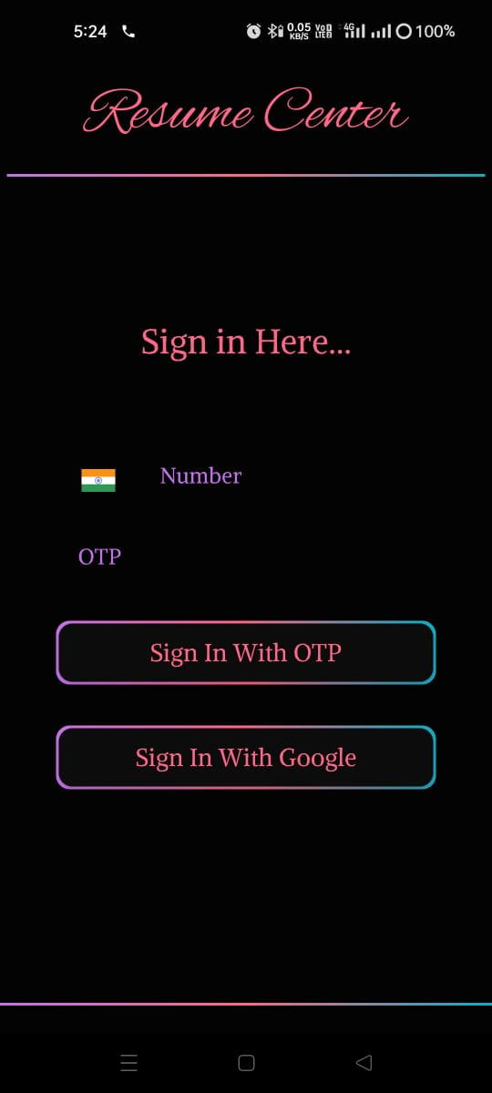

* Users can sign in to the app from this screen. Using Mobile Number with OTP.

3 - Sign In Screen

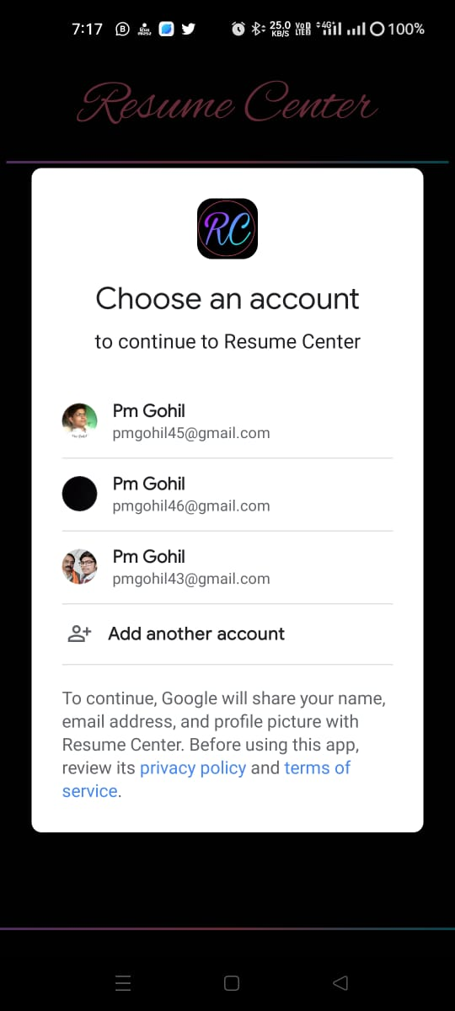

* Users can sign in to the app from this screen. Using Google Mail Account.

4 - Home Screen

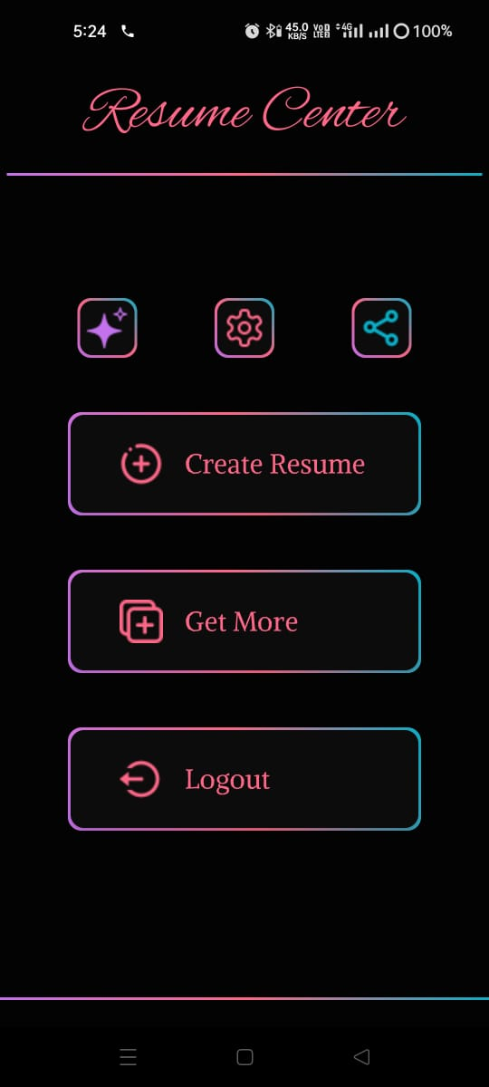

* The reason why this screen is the app's Home screen is because it appears when a user starts the app for the first time.

5 - Personal Information Screen

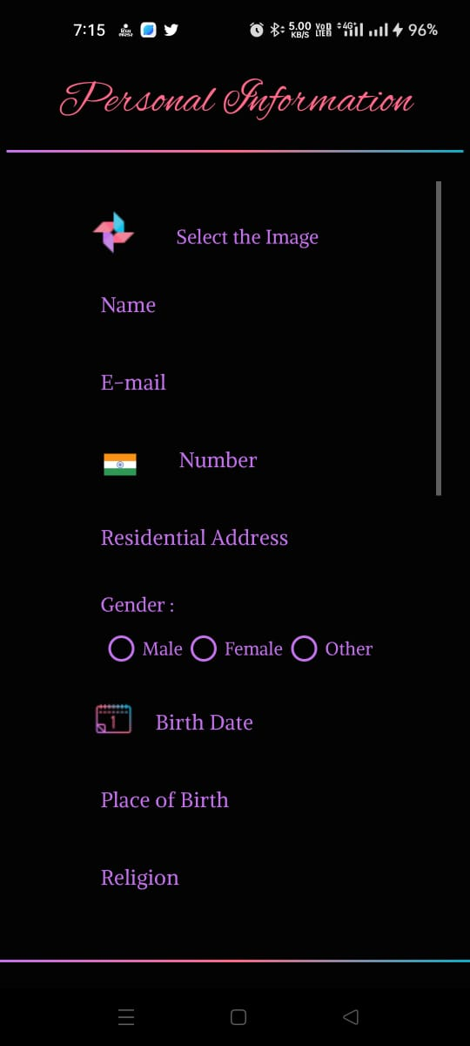

* User can insert our Personal Information on this screen and click next to open next Screen.

6 - Educational Information Screen

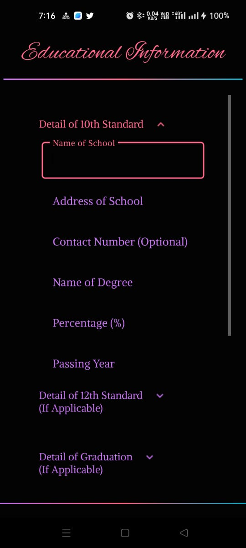

* User can insert our Educational Information on this screen and click next to open next Screen and also can do skip page.

7 - Experience Information Screen

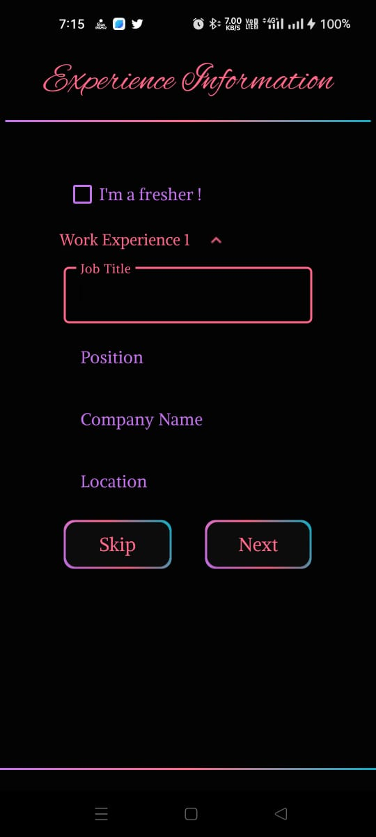

* User can insert our Job Experience Information on this screen and click next to open next Screen and also can do skip page.

8 - Skill Information Screen

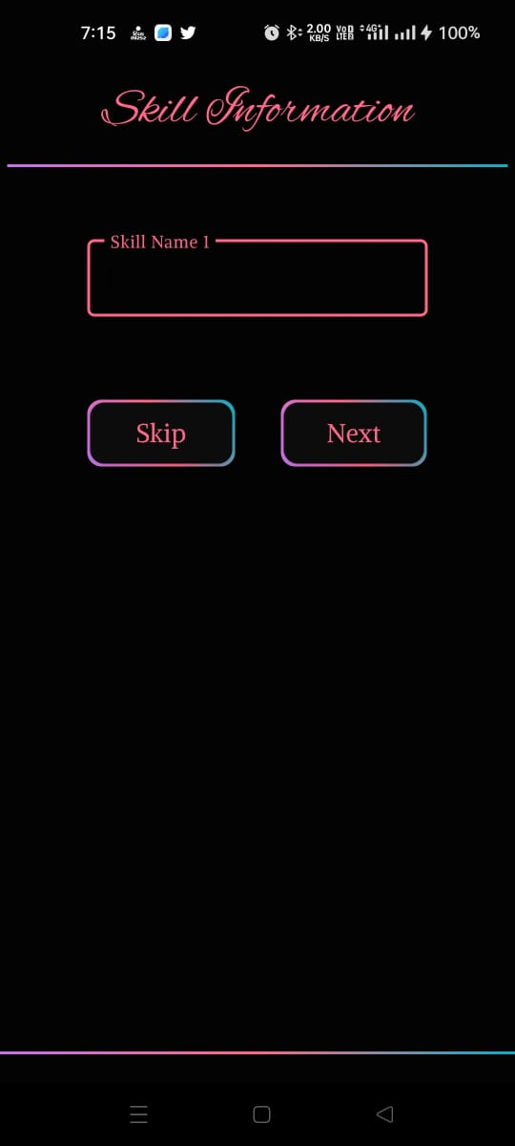

* User can insert our Skill Information on this screen and click next to open next Screen and also can do skip page.

9 - Reference Information Screen

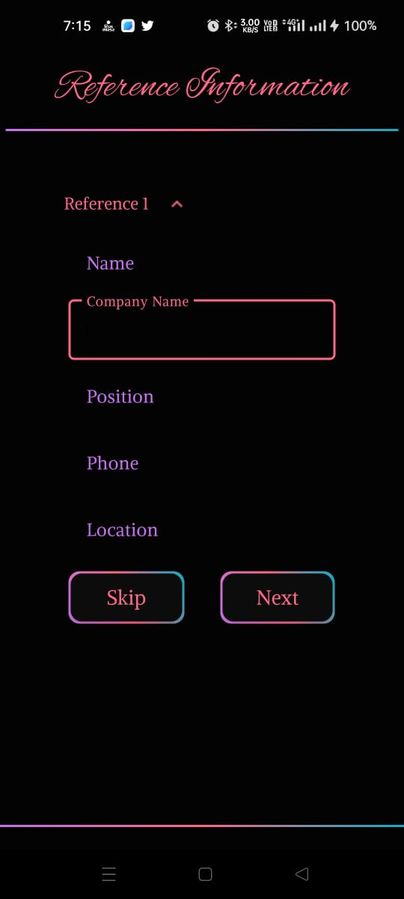

* User can insert our Reference Information on this screen and click next to open next Screen and also can do skip page.

10 - Resume Themes Screen

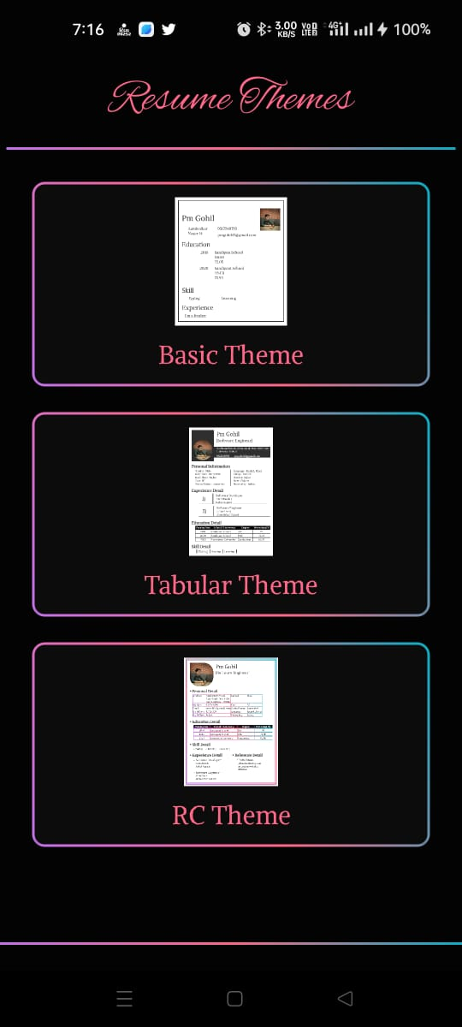

* User can see themes of resume which u want create on this screen and click next to open next Screen.

11 - RC Themes Screen

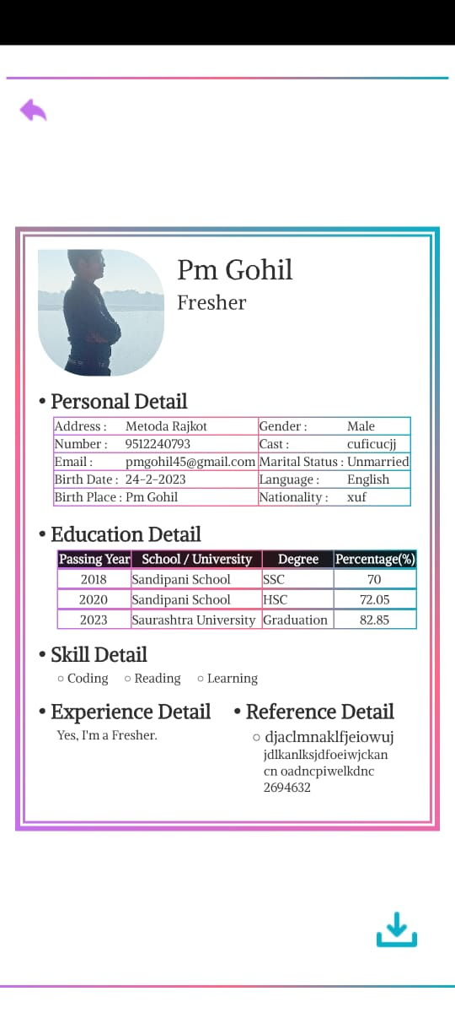

* User can see our resume detail on this screen and click on download button he/she get the image of our resume and he/she also click on back to come on previous screen.

12 - Setting Screen

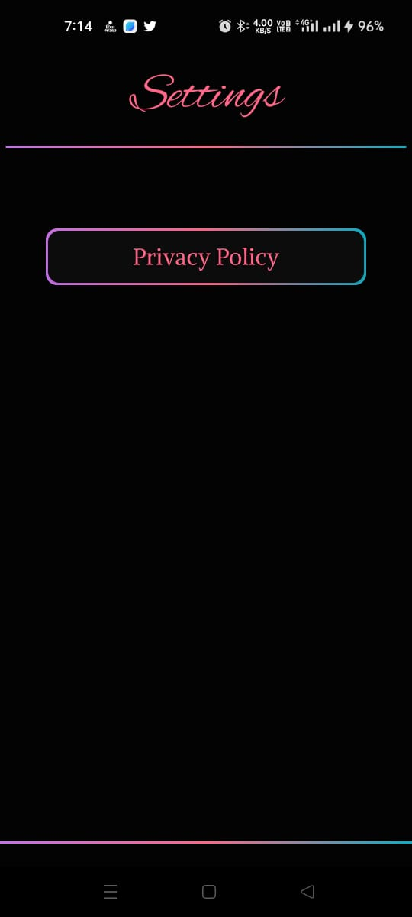

* If user want to a read resume center app policy than user can check out the setting menu and click on Privacy Policy and see our policy.

1. - Share App Screen

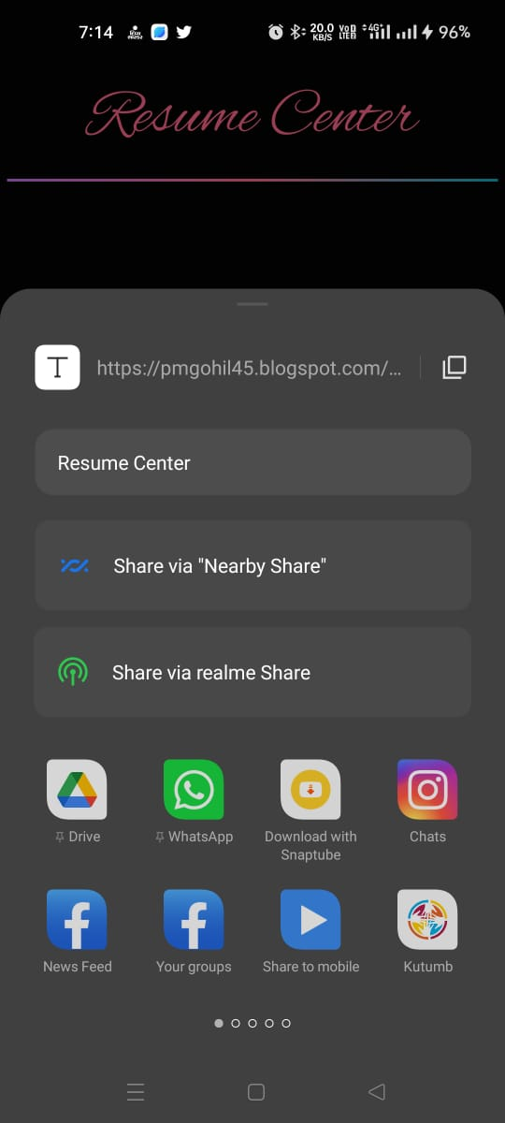

* If user want to a share resume center app on any social media app than user can click on share button and share resume center app.

**Test Cases**

|  |  |  |  |
| --- | --- | --- | --- |
| **Test Case** | **Description** | **Actual Output** | **Test Result** |
| Splash Screen | Show User to animation right to left come or go. | Show User to animation right to left come or go. | **Pass** |
| Sign In  Screen | Allows users to sign in for the app and return to the home screen after a successful authentication. | Allows users to sign in for the app and return to the home screen after a successful authentication. | **Pass** |
| Home  Screen | Displays create resume, share, setting, logout, more menu | Displays create resume, share, setting, logout, more menu. | **Pass** |
| Personal Information Screen | Information Insert successfully on firebase. | Information Insert successfully on firebase. | **Pass** |
| Educational Information Screen | Information Insert successfully on firebase. | Information Insert successfully on firebase. | **Pass** |
| Experience Information Screen | Information Insert successfully on firebase. | Information Insert successfully on firebase. | **Pass** |
| Skill Information Screen | Information Insert successfully on firebase. | Information Insert successfully on firebase. | **Pass** |
| Reference Information Screen | Information Insert successfully on firebase. | Information Insert successfully on firebase. | **Pass** |
| Resume Theme Screen | Display a resumes theme. | Display a resumes theme. | **Pass** |
| Theme Screen | Successfully fetch data on resume theme | Successfully fetch data on resume theme | **Pass** |
| Download | Successfully download resume. | Successfully download resume. | **Pass** |
| Back | Successfully move on back screen. | Successfully move on back screen. | **Pass** |
| Setting | Click on setting icon and display the privacy policy menu. | Click on setting icon and display the privacy policy menu. | **Pass** |
| Privacy Policy | Display the privacy policy.. | Display the privacy policy.. | **Pass** |
| Share | Successfully share app on social media | Successfully share app on social media | **Pass** |
| Logout | Click on this button and move to sign in screen. | Click on this button and move to sign in screen. | **Pass** |

**Limitation**

* Though we tried our best in developing this system but as limitations are mere parts of any system so are of our system. Some limitations of innovator to investors portal are as under :
* Data load slowly.
* Only some limited functionality available right now.

**Future Enhancement**

* Trying to remove the many limitations.
* Share resume PDF.
* More easy implementation environment.
* Reduce the database load.

**Webliography**

* [**https://www.youtube.com/**](https://www.youtube.com/)
* [**https://stackoverflow.com/**](https://stackoverflow.com/)
* [**https://kotlinlang.org/**](https://kotlinlang.org/)
* [**https://developer.android.com/**](https://developer.android.com/)
* [**https://github.com/**](https://github.com/)